**Figure S1.** Relationships of individual predator productivity with prey abundance at distinct locations throughout the central/southern CCS. All x-axes represent prey abundance, while all y-axes represent predator productivity. Abundance of

**I)** anchovy prey relative to productivity of a) Brandt’s cormorants at SE Farallon Island (SFI), b) Año Nuevo Island (ANI) and c) Alcatraz Island (ALZ), d) common murre at SFI, e) rhinoceros auklet at SFI and f) ANI, g) brown pelican at Santa Barbara Island (SBI) and h) Anacapa Island (ANA), i) least tern at Venice Beach (VB), and j) California sea lions at San Miguel Island (SMI) k) San Clemente Island (SCI), l) SBI, and m) San Nicolas Island (SNI);

**II)** juvenile rockfish prey relative to productivity of a) common murre at SFI, b) rhinoceros auklet at SFI and c) ANI, d) pelagic cormorant at SFI and e) ANI, f) pigeon guillemot at SFI, and g) Chinook salmon from the Central Valley fall run (CV).

**III)** sardine prey relative to a) productivity of sea lions at (SMI) and b) Chinook salmon from CV; and

**IV)** market squid prey relative to productivity of a) common murre at SFI, b) rhinoceros auklet at SFI and c) ANI, and d) sea lions at SMI. As in Table A2, in all cases for which there were sufficient observations but the model did not converge to calculate a threshold, data in the upper left quadrant of curve, when prey abundance was high yet predator productivity was low, signaled alternate prey use precluding a significant relationship with just one prey species.

Black lines indicate models with EDF<=2 (linear) according to GAM

Pink lines have EDF<=2, and do look linear according to GAM, but are influenced by alternate prey in upper left quadrant so still include these.

Blue lines have EDF<=2, but do NOT look linear!! *Check w/ Grant.*

Red lines have EDF>2 (due to points down in lower left), but LOOK LINEAR! WHICH DO WE GO WITH???

Yellow lines are new figs from Grant

Circled are relationships for which model did not converge and no threshold was produced, could be dropped.

Red circles indicate relationship likely driven by just one low point and therefore this model could be dropped.

Orange circles indicate relationship driven by more than just one low point and unduly influenced by points in upper left quadrant of graph (prey-switching) so should probably keep.

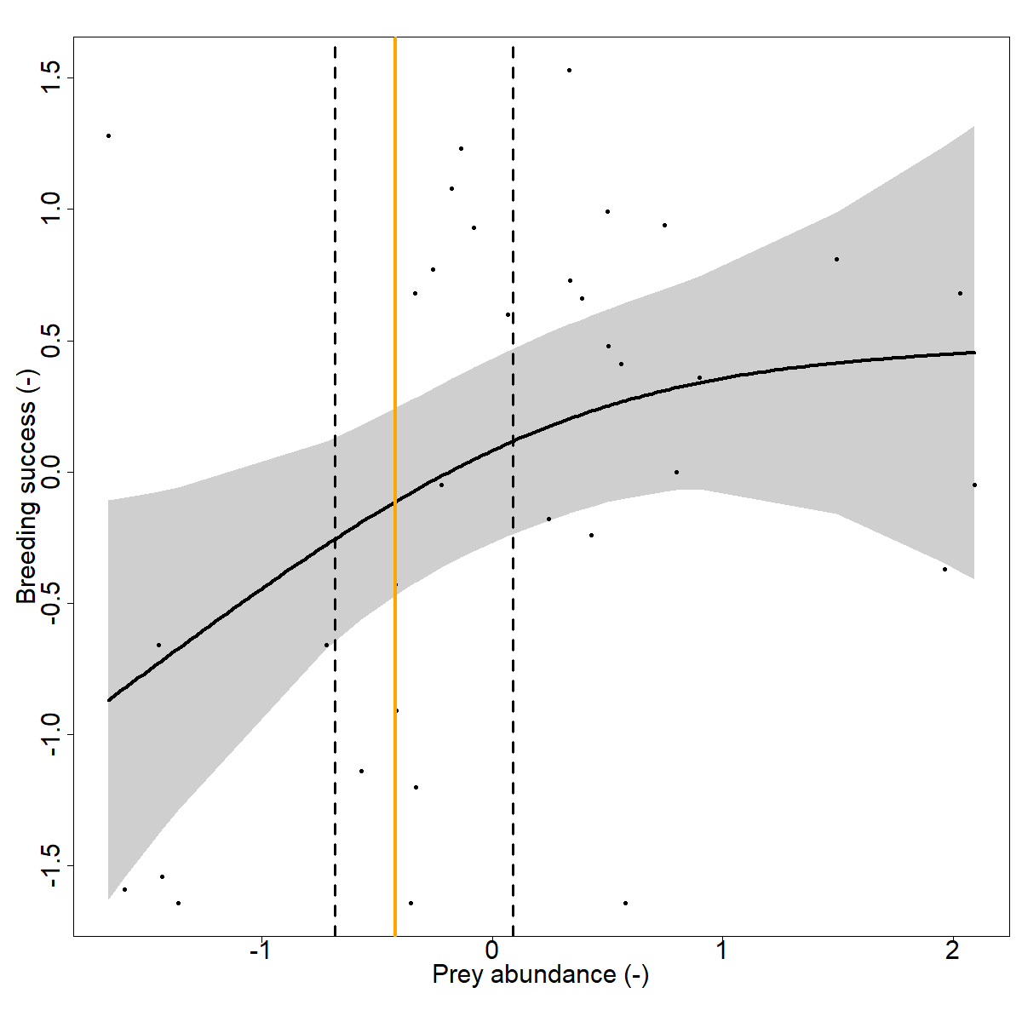 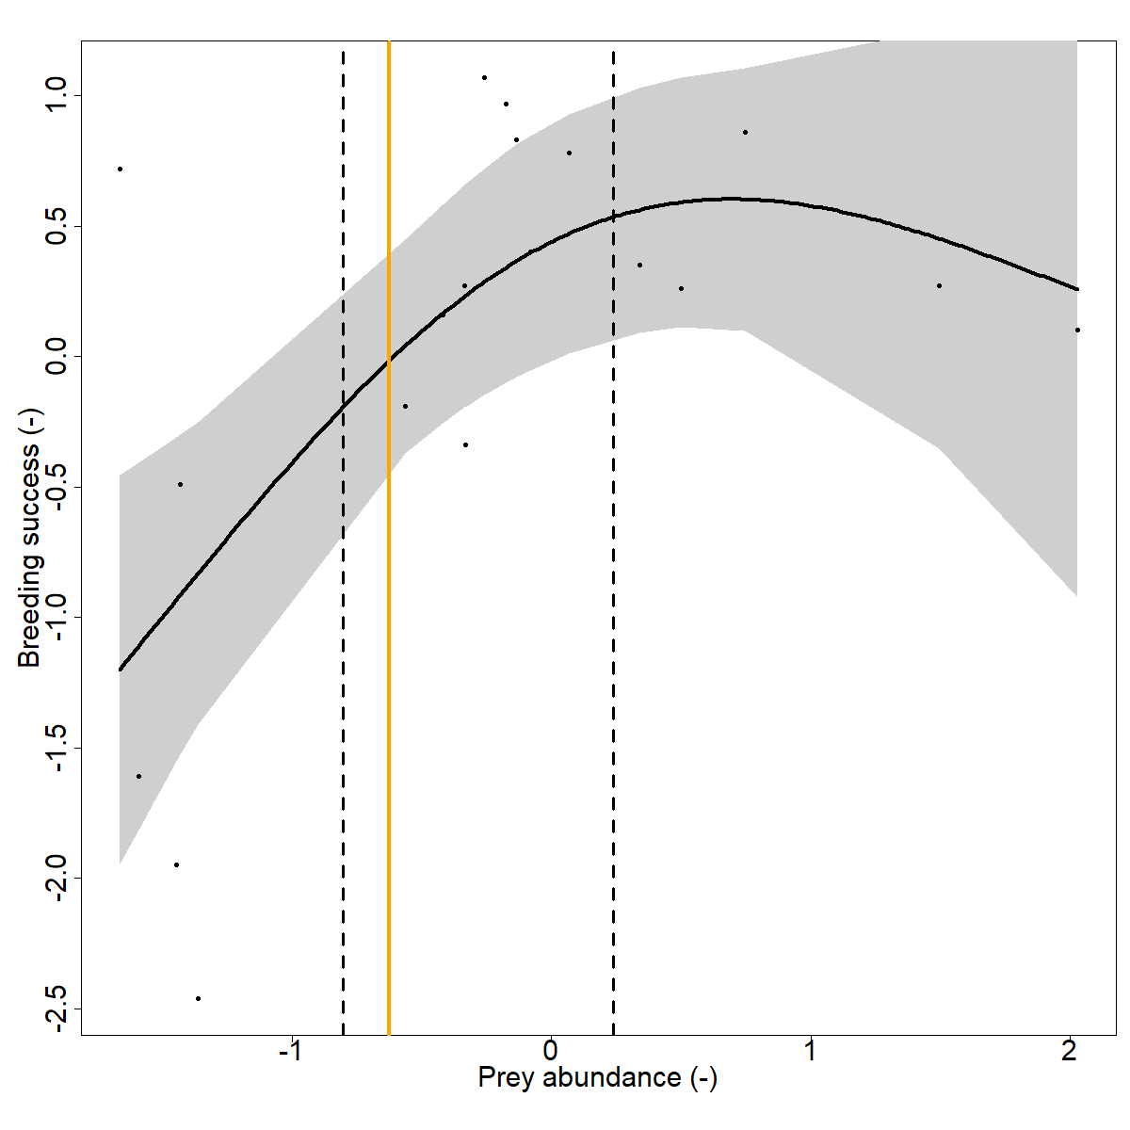 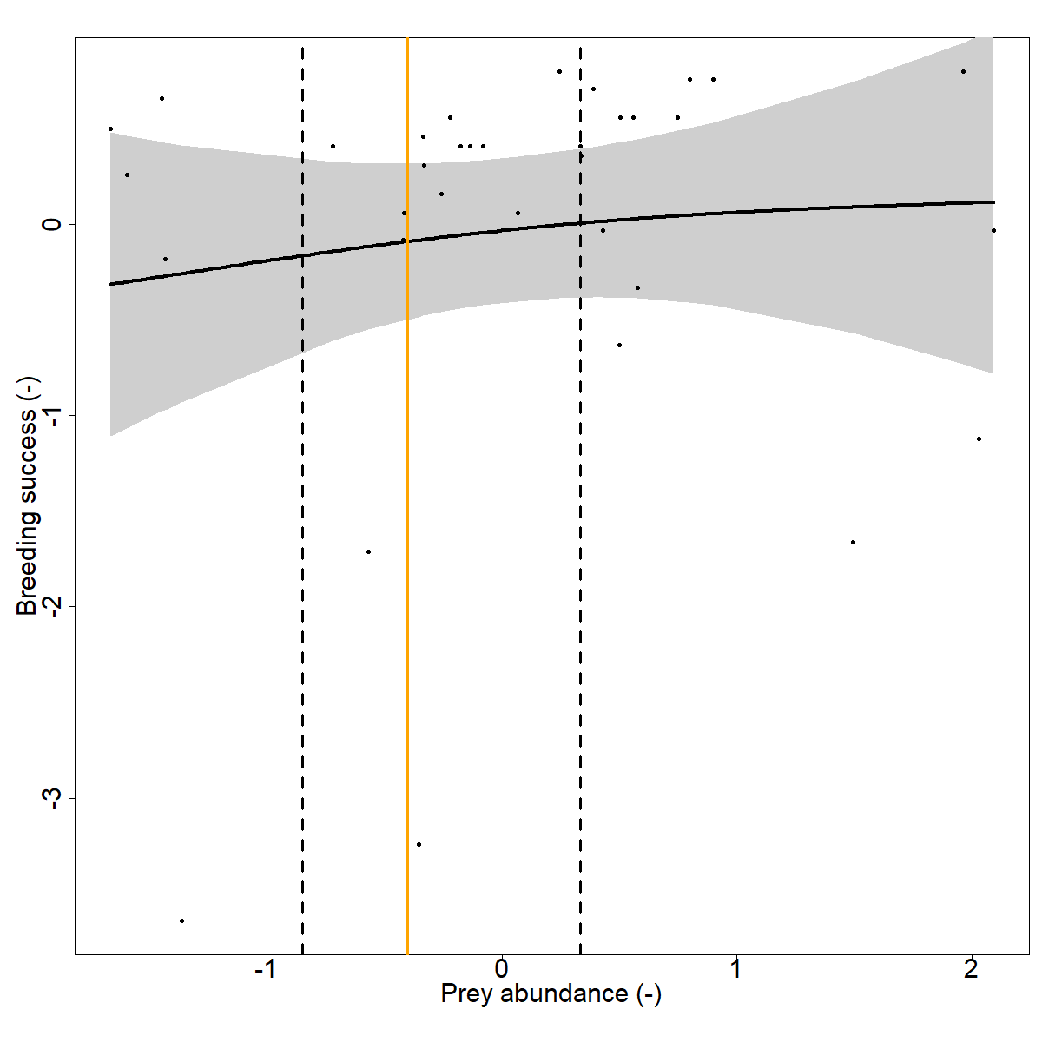 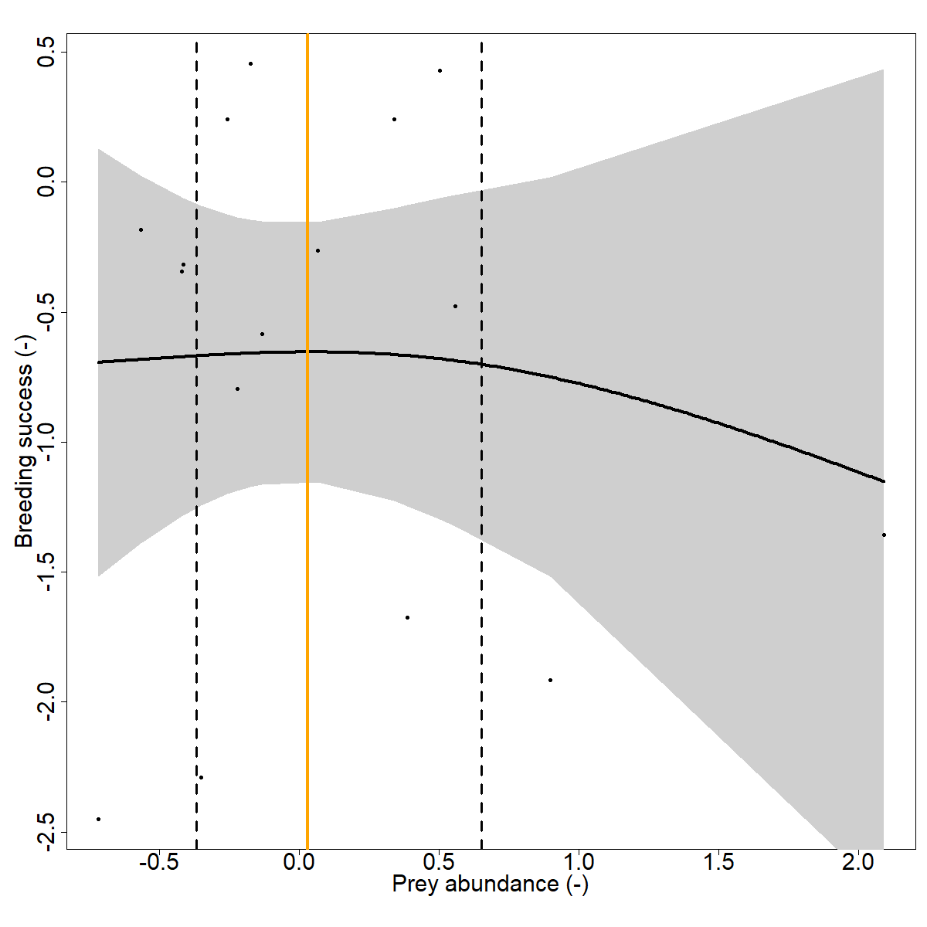

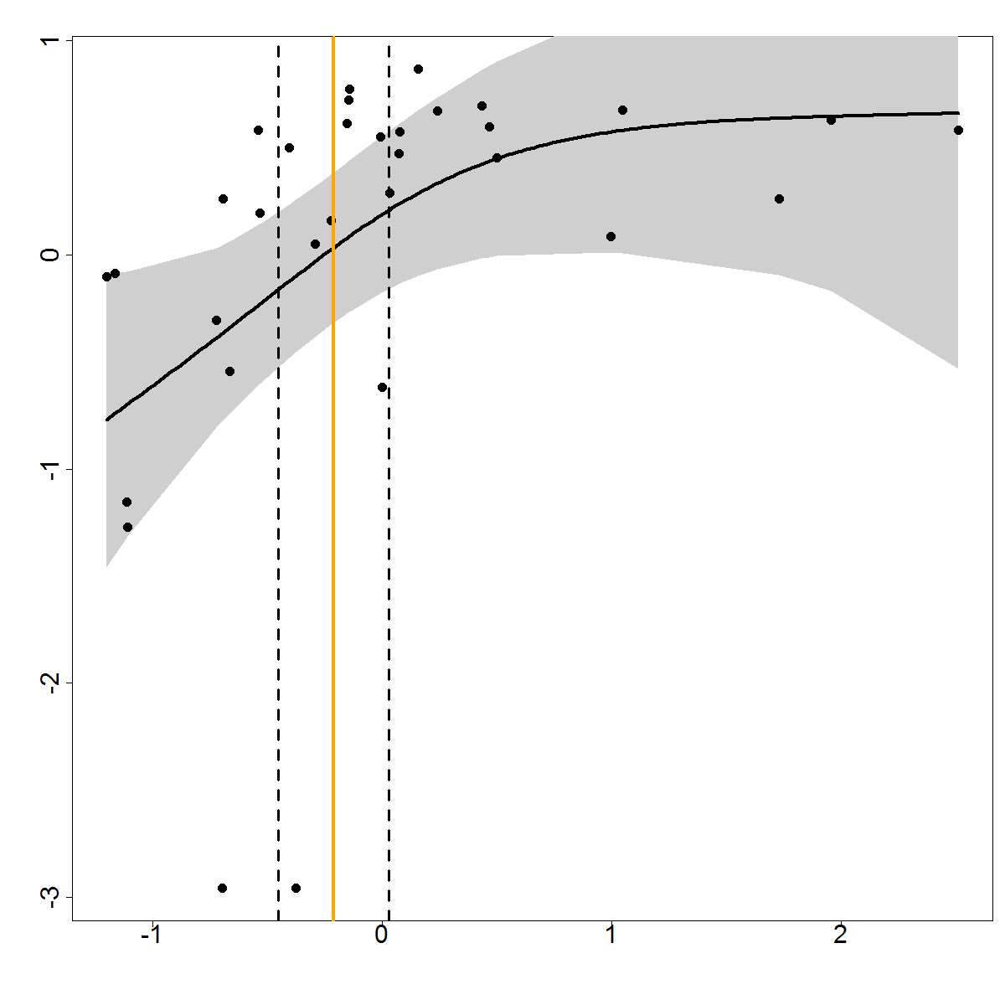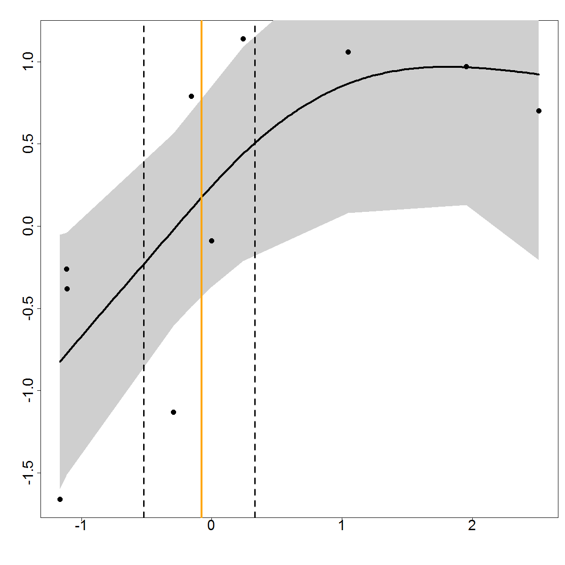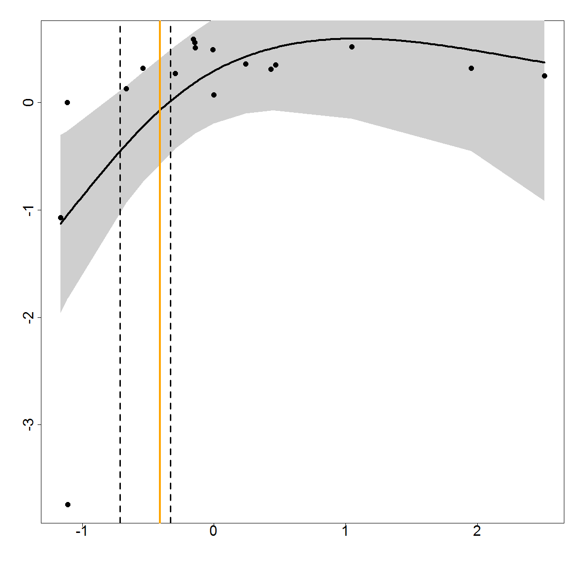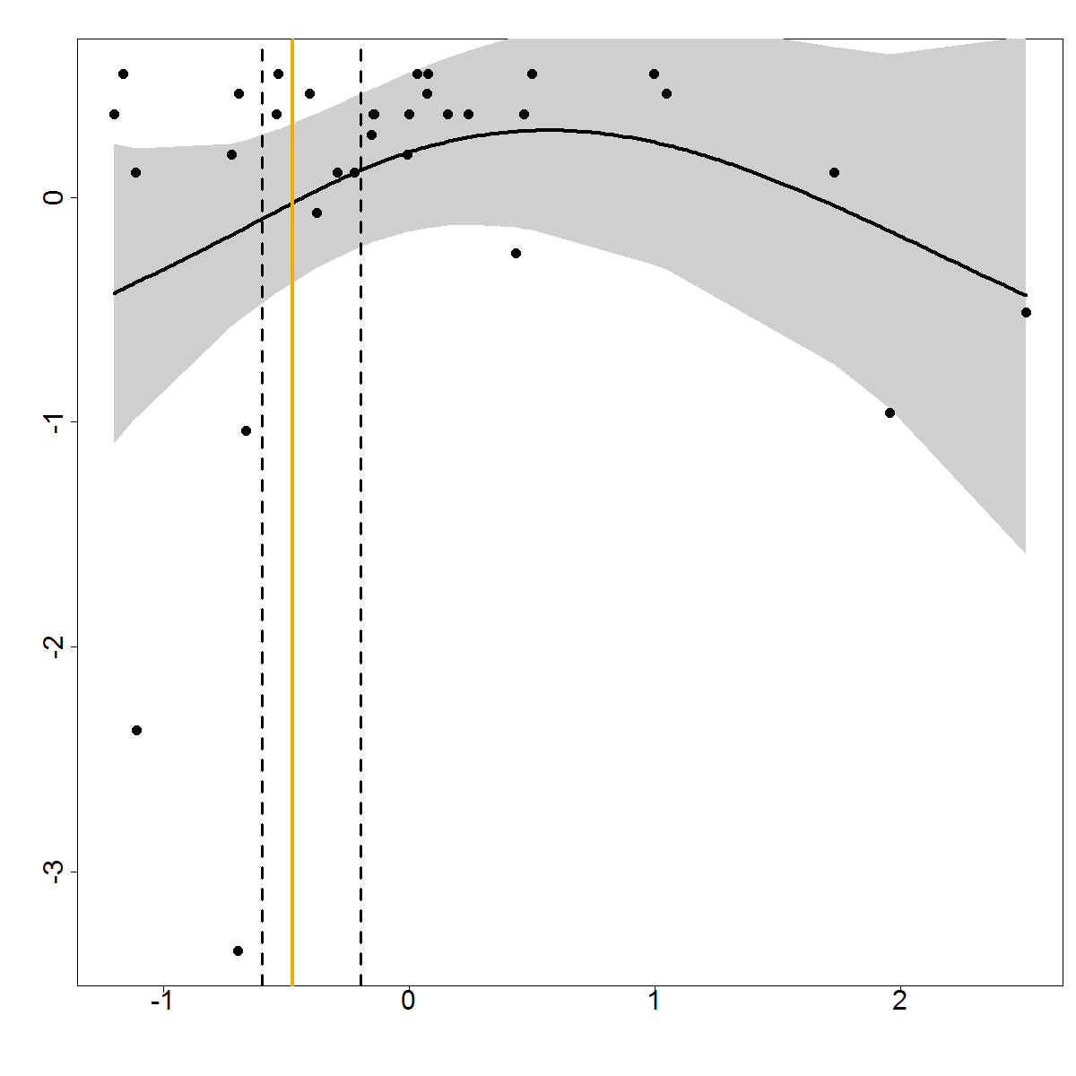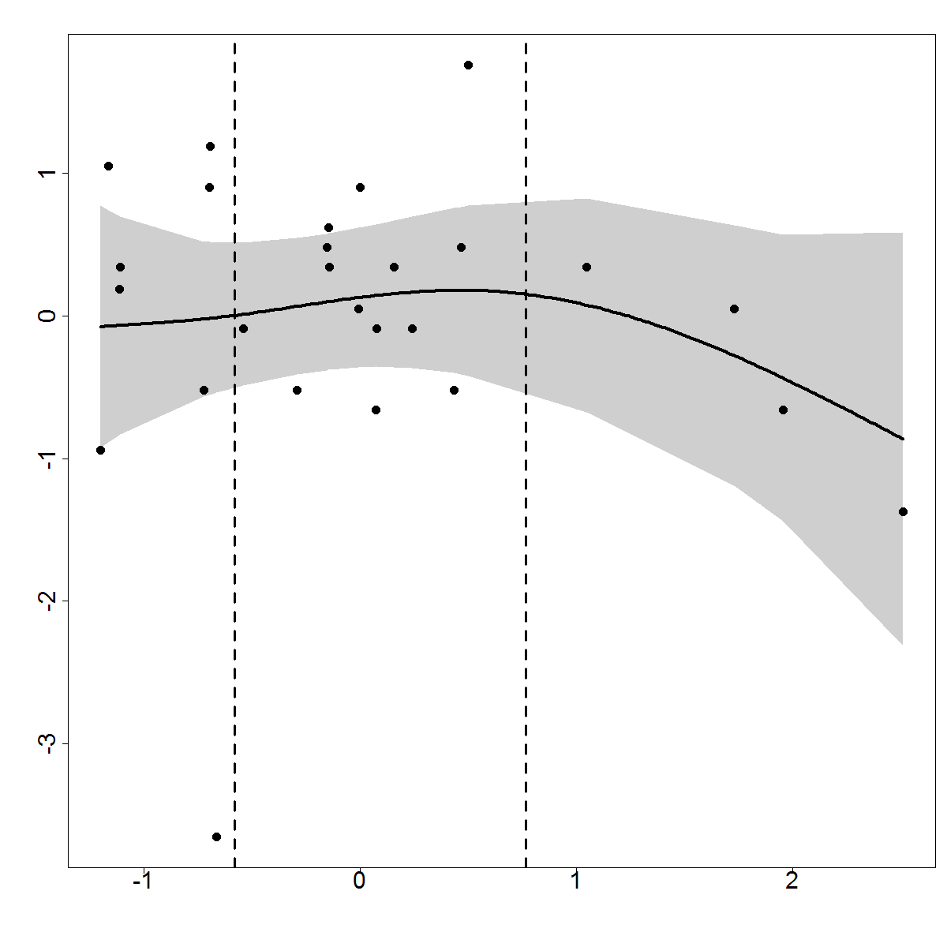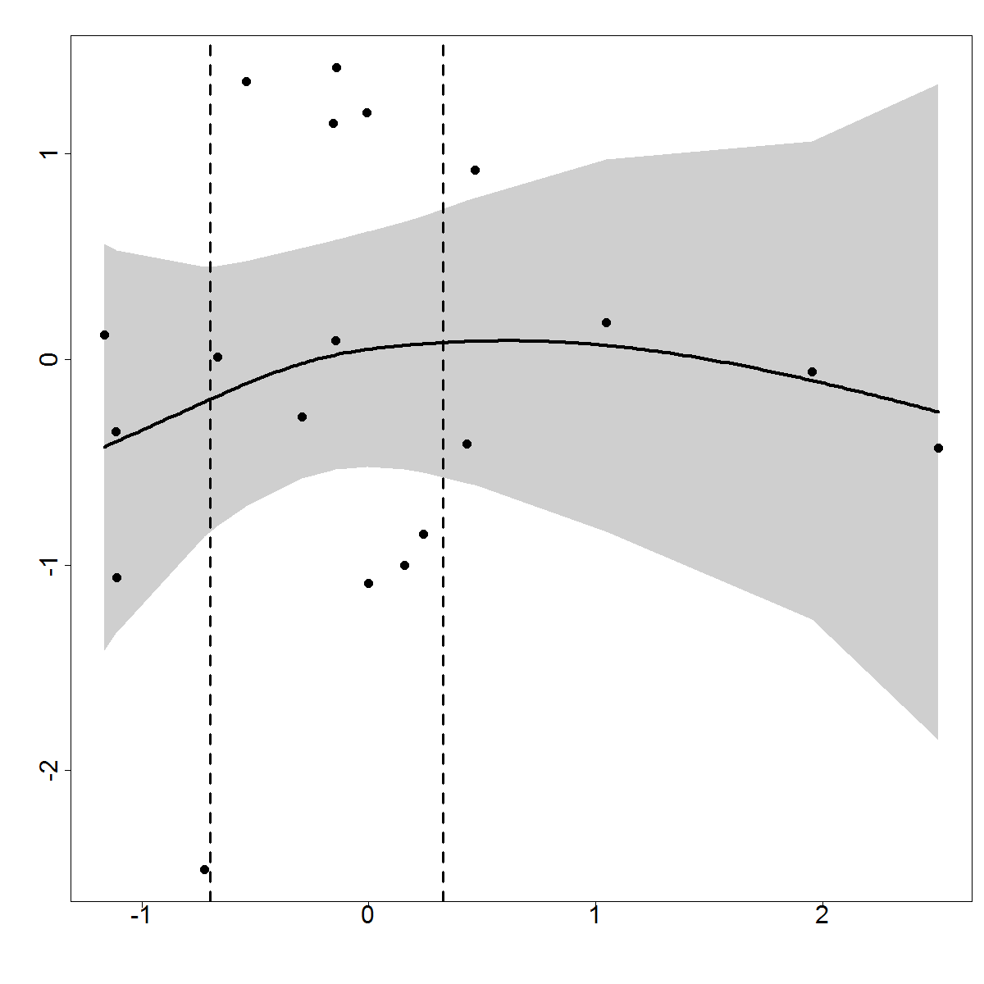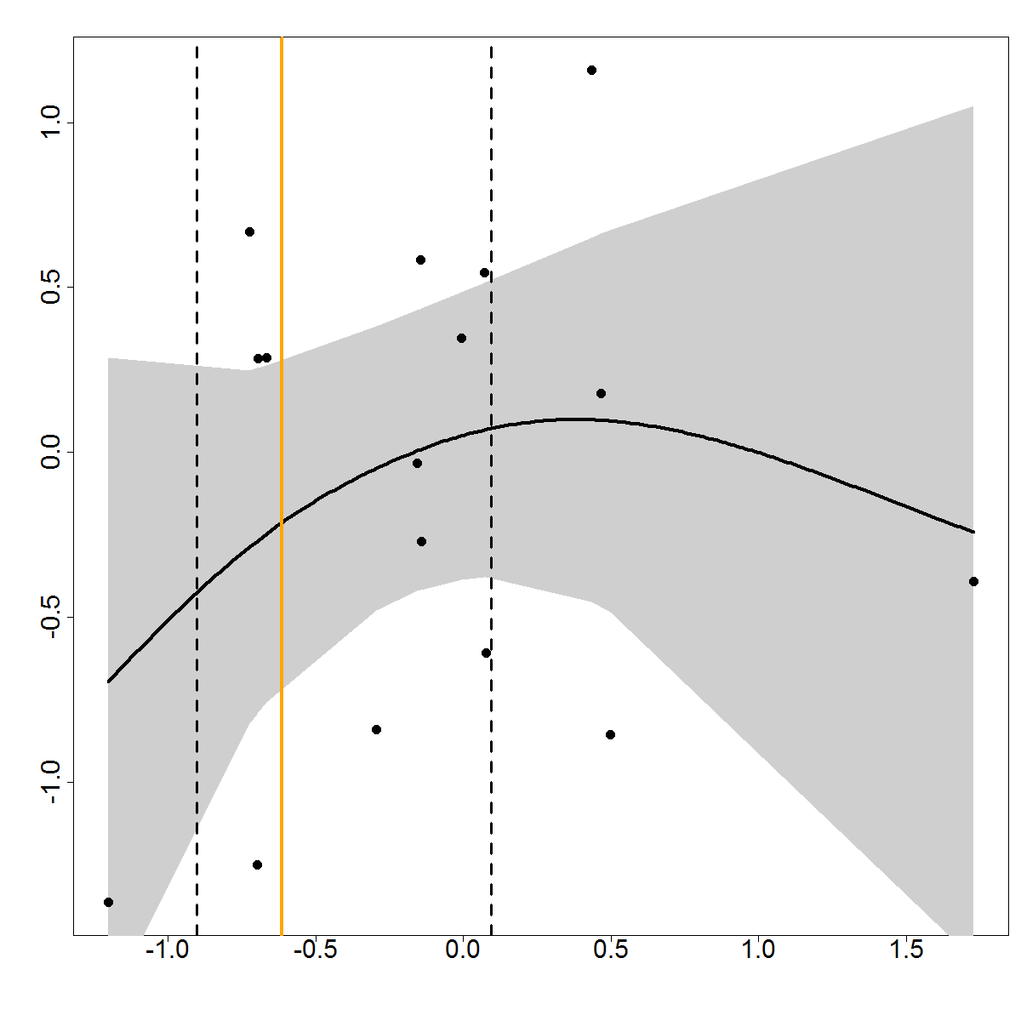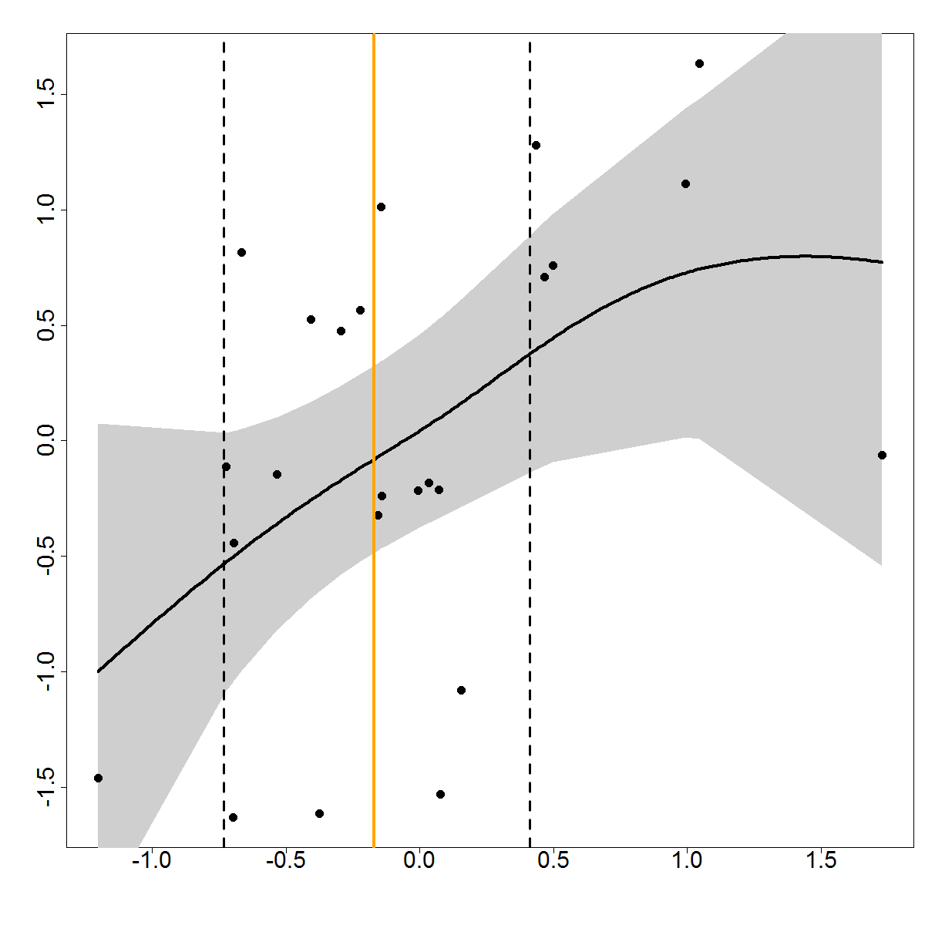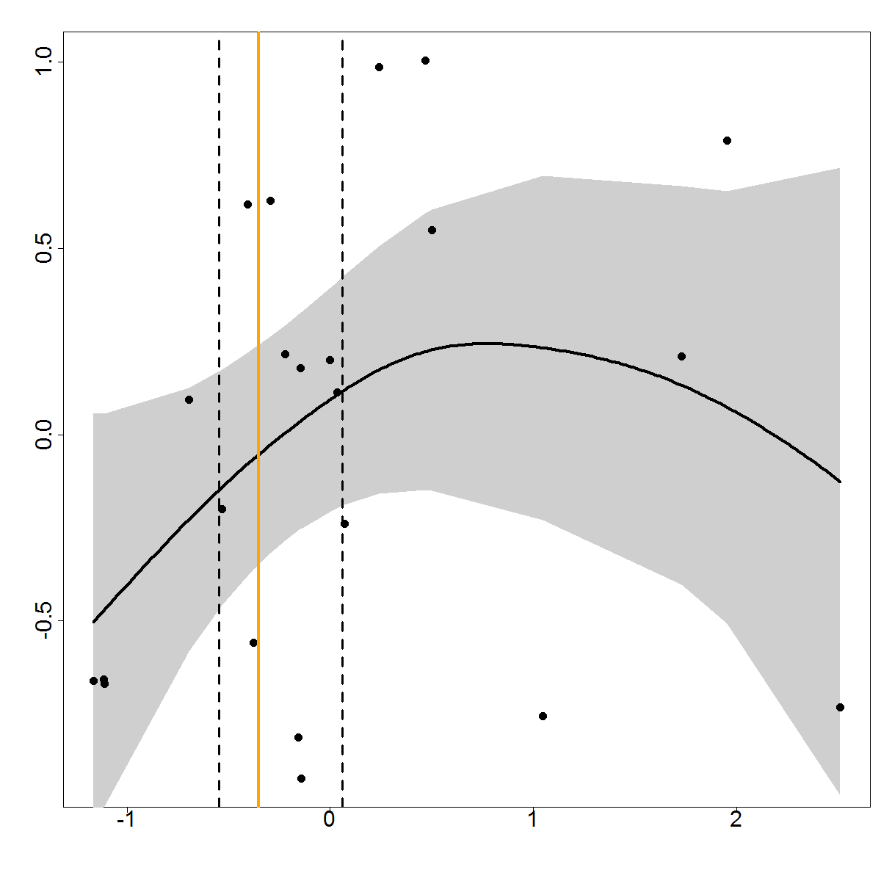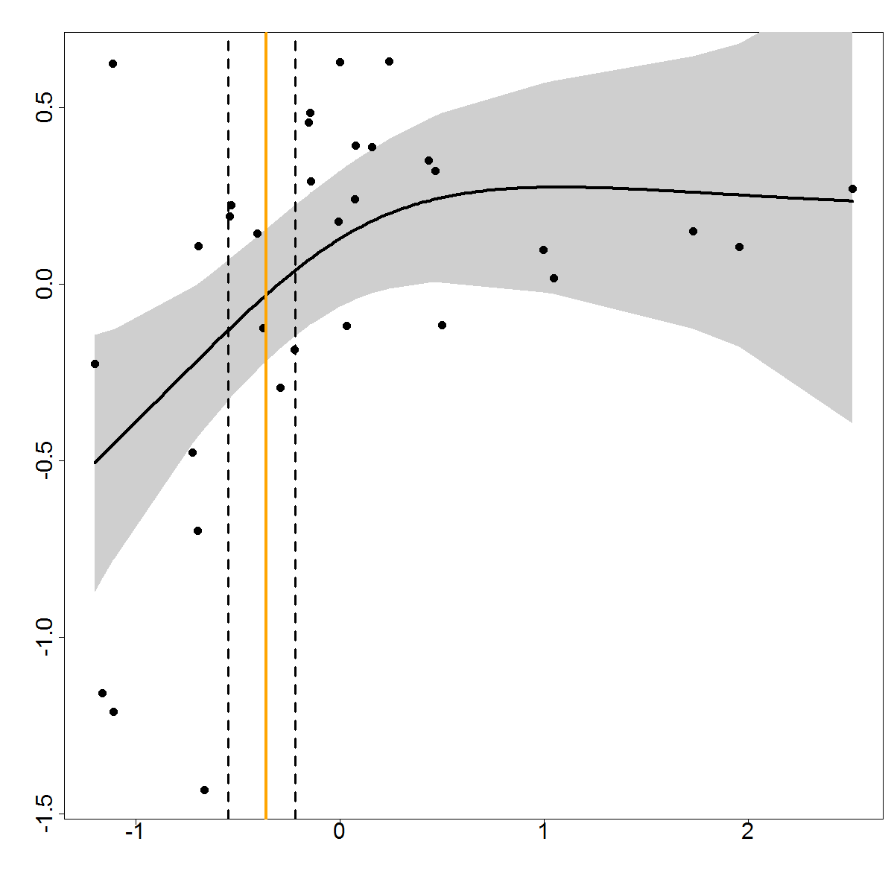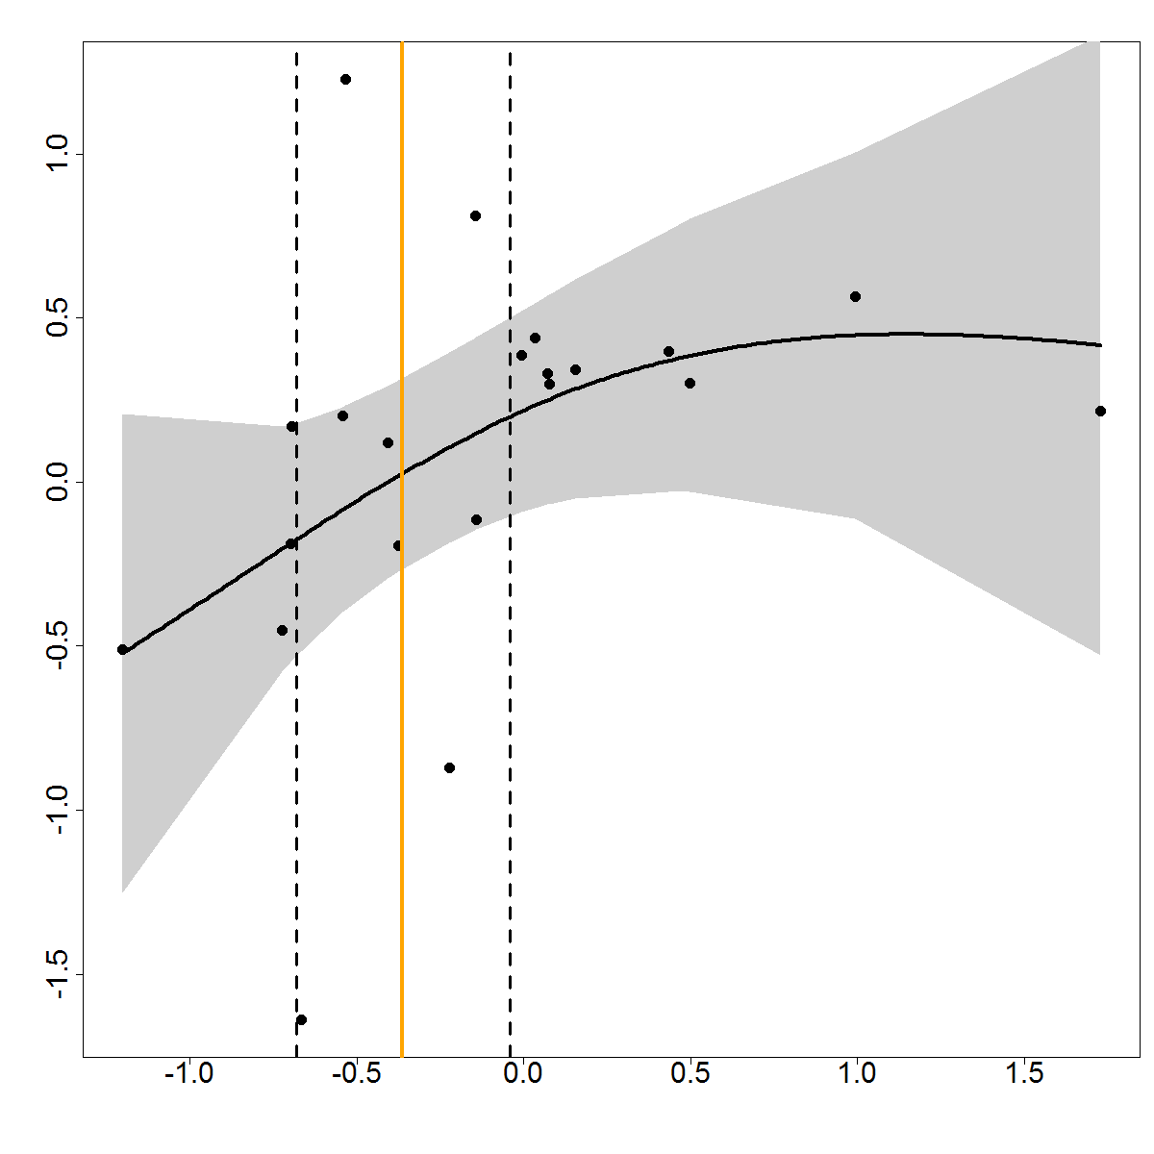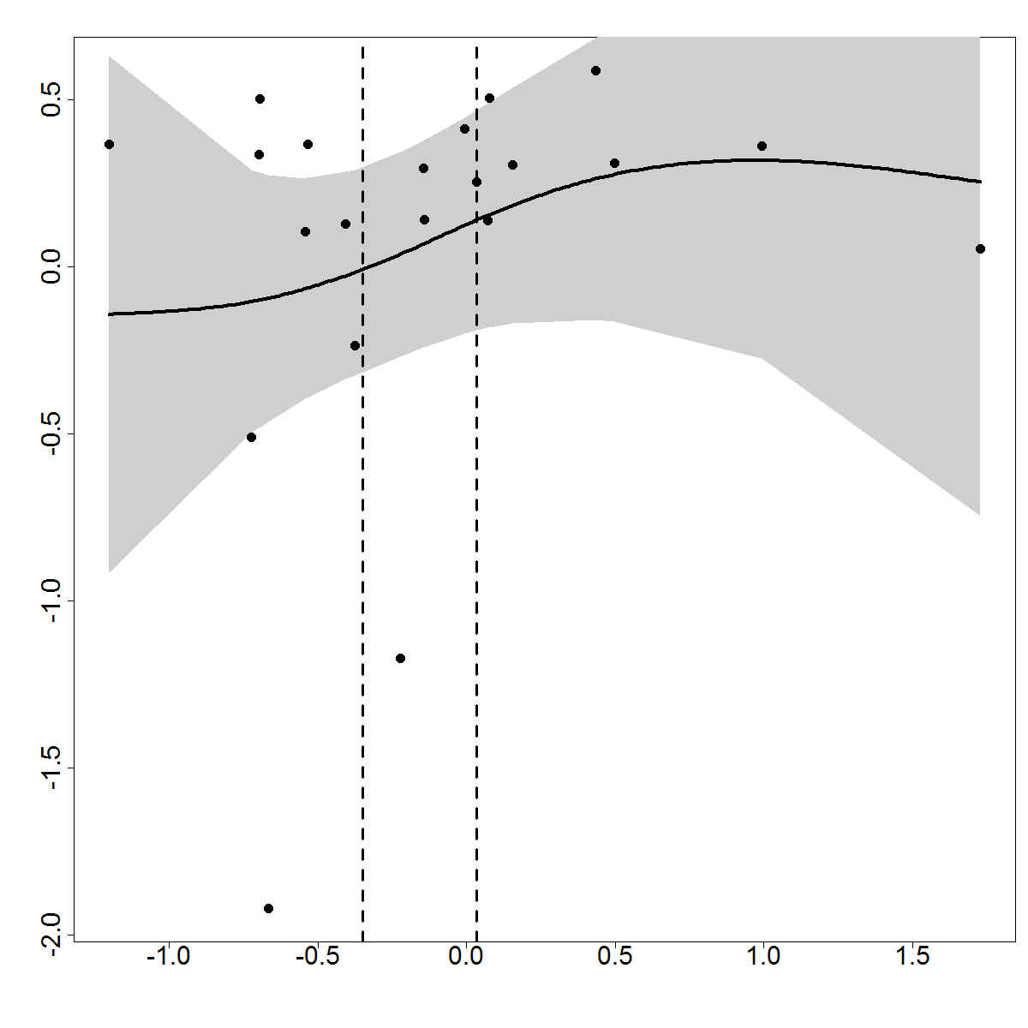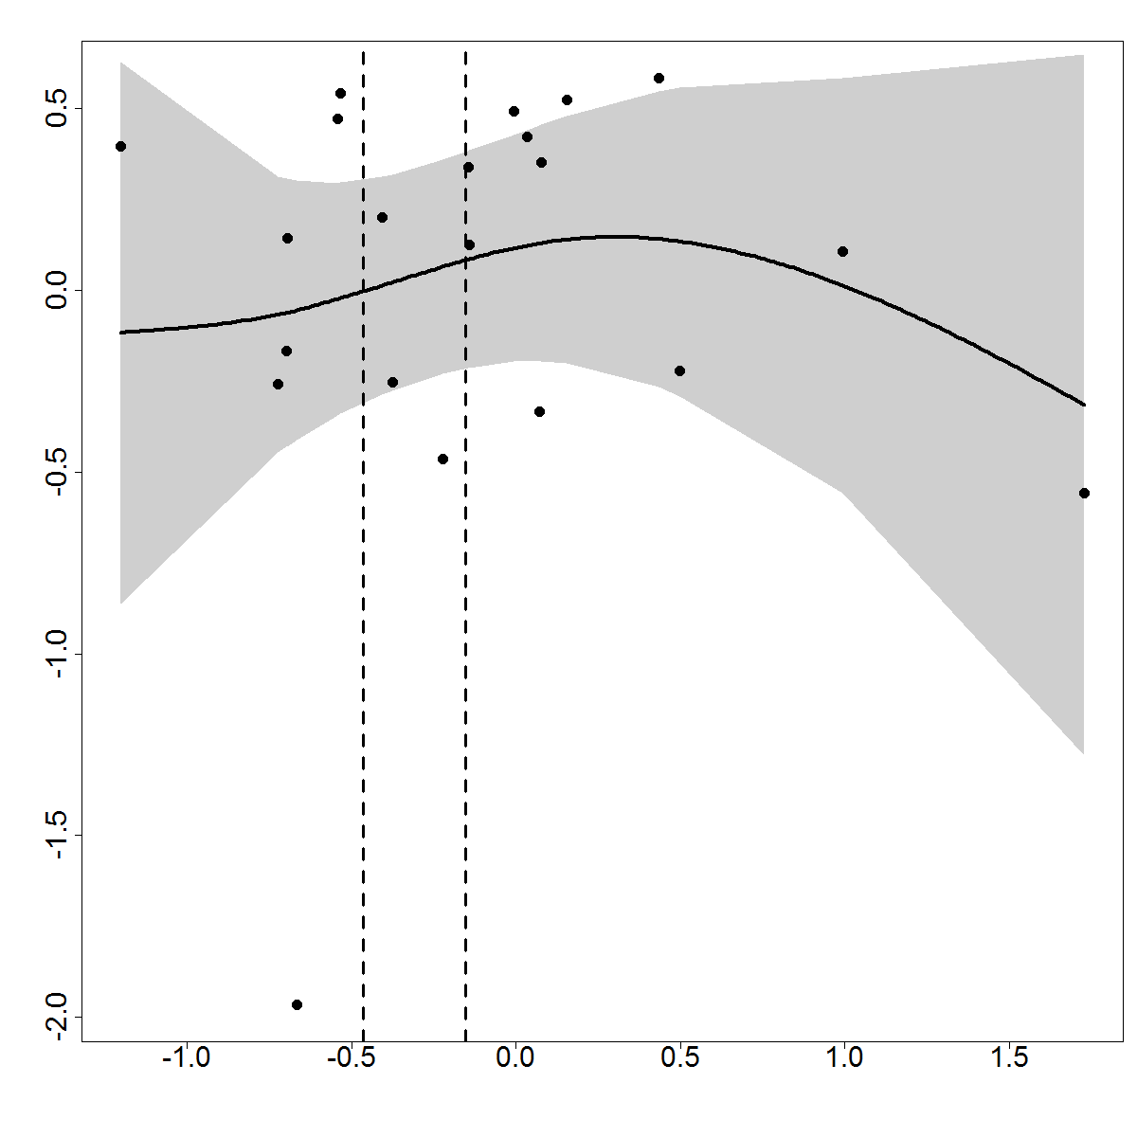

**I**

h

i

j

k

l

m

d

c

g

e

f

b

a

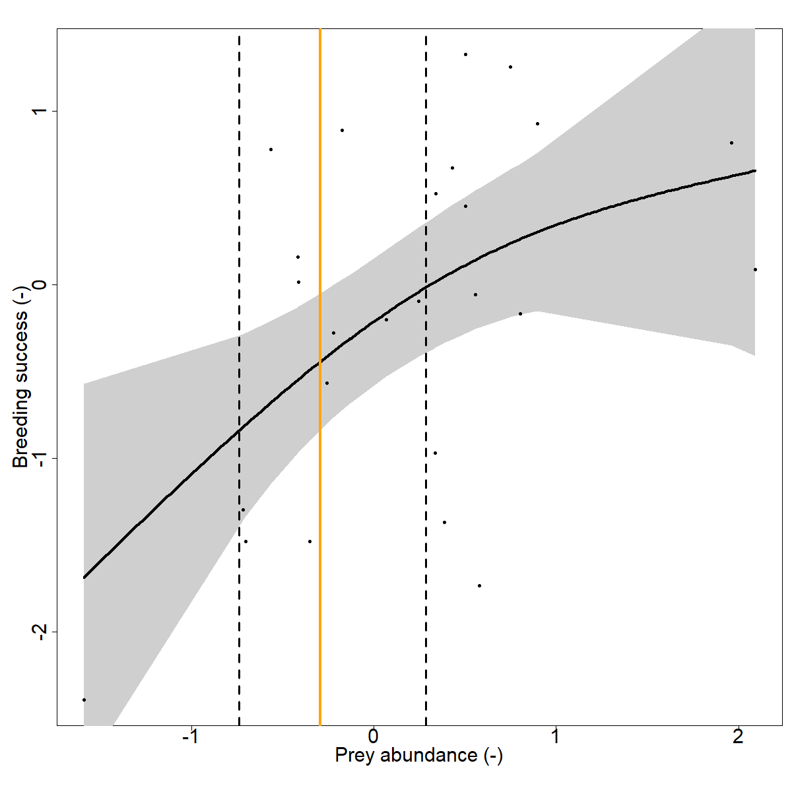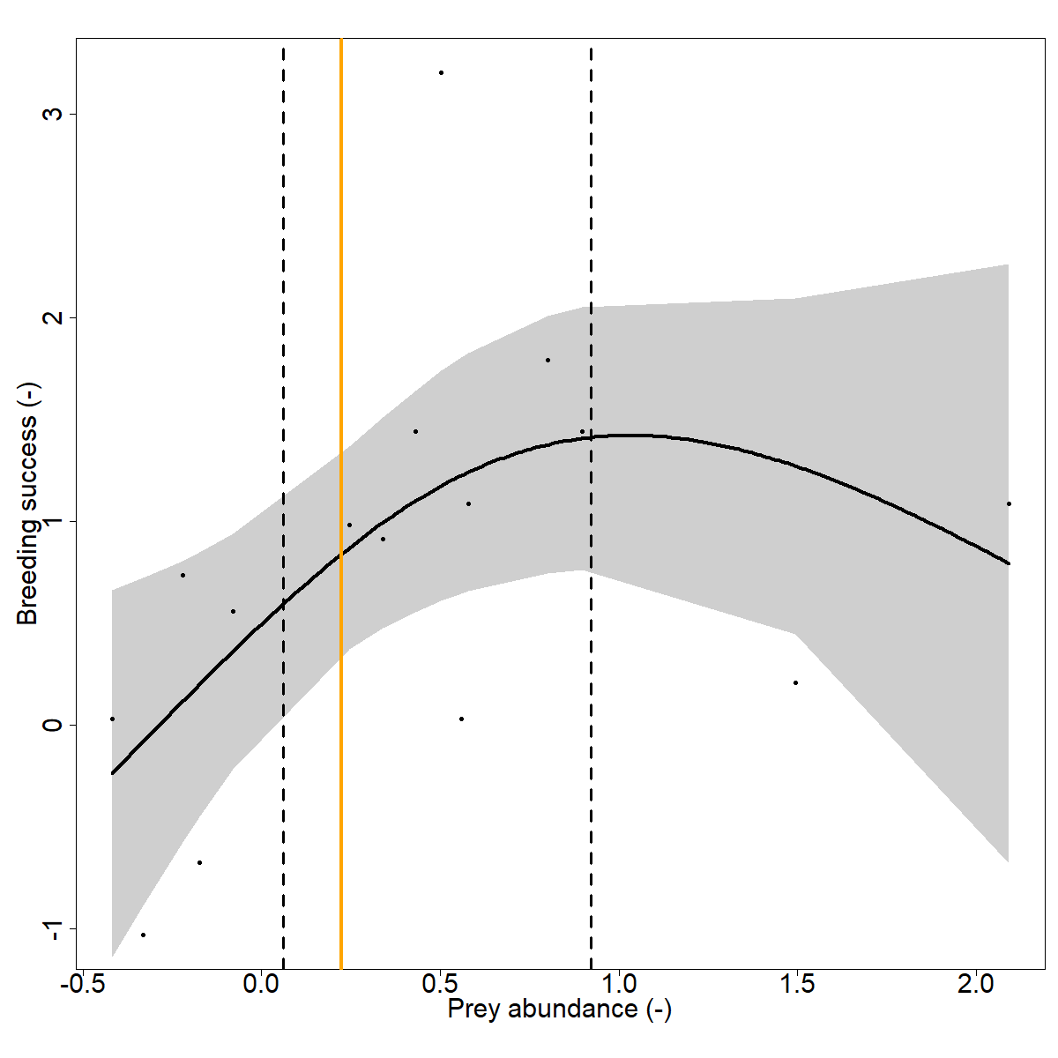 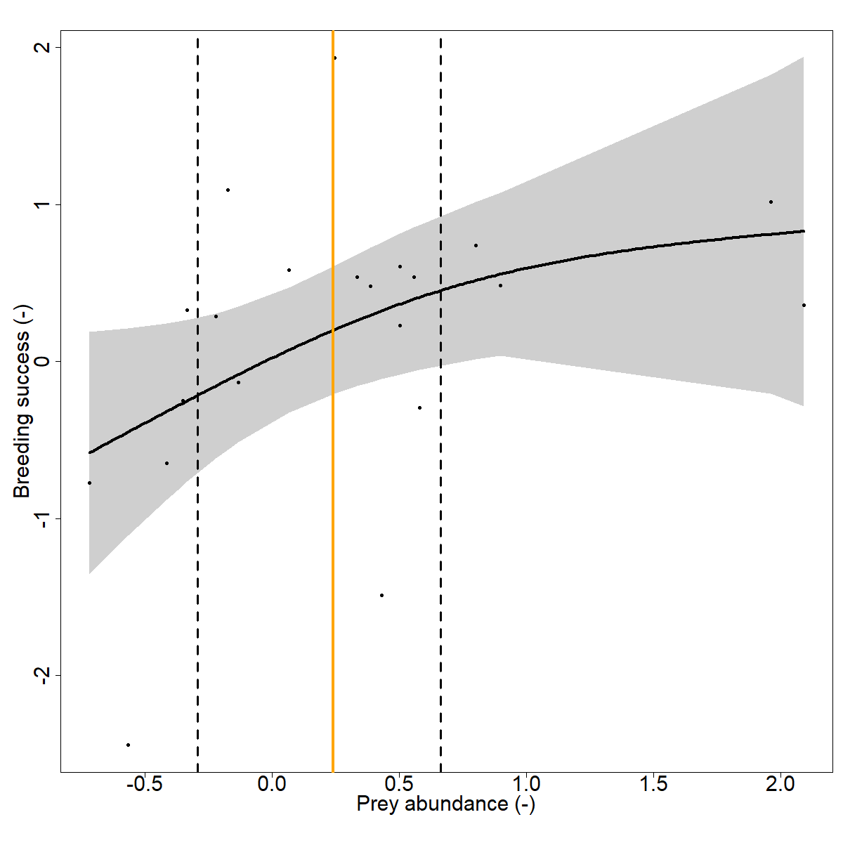

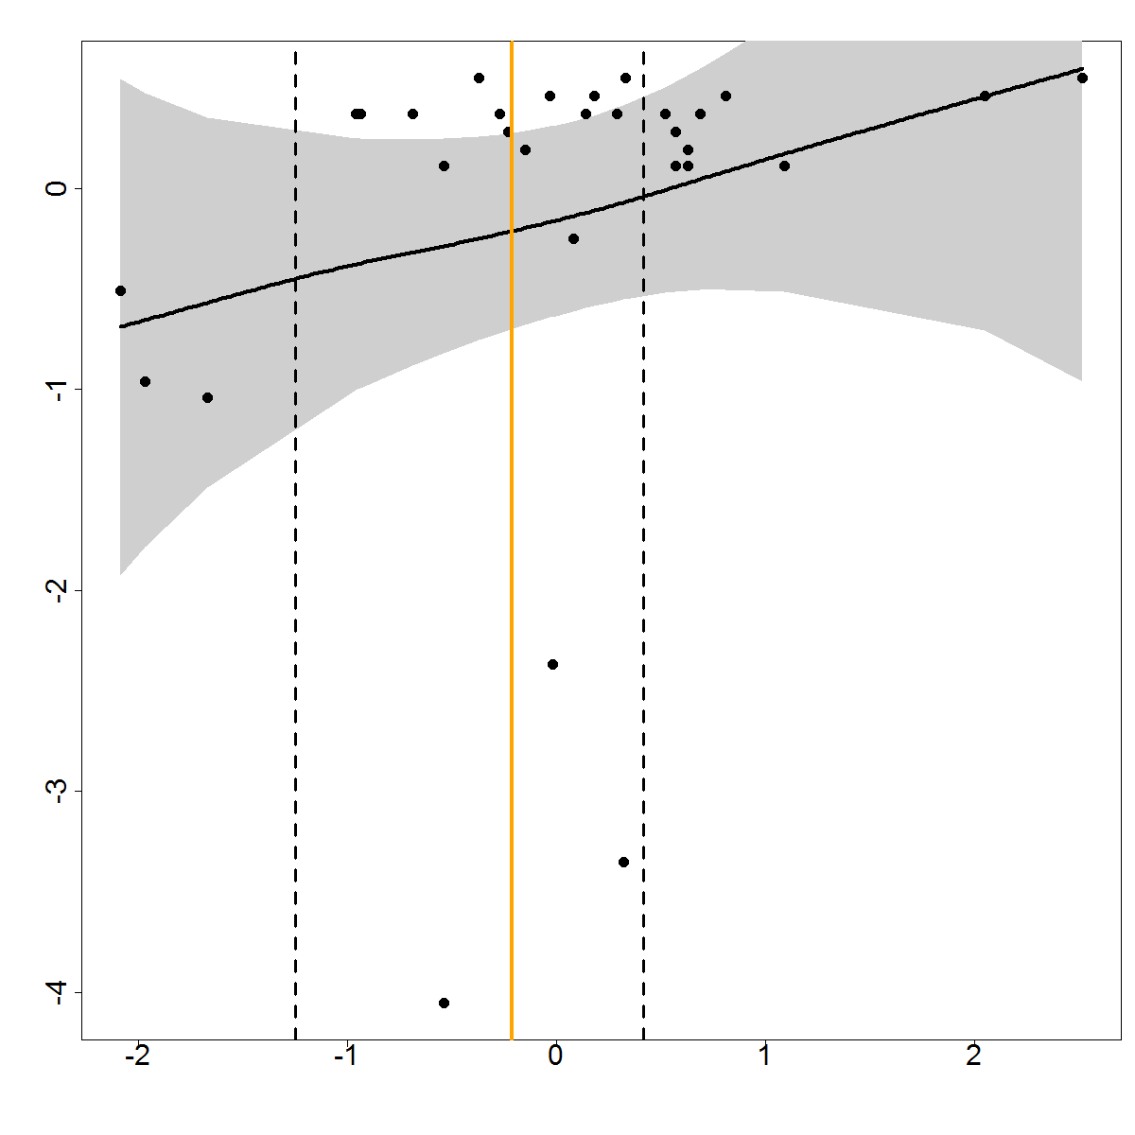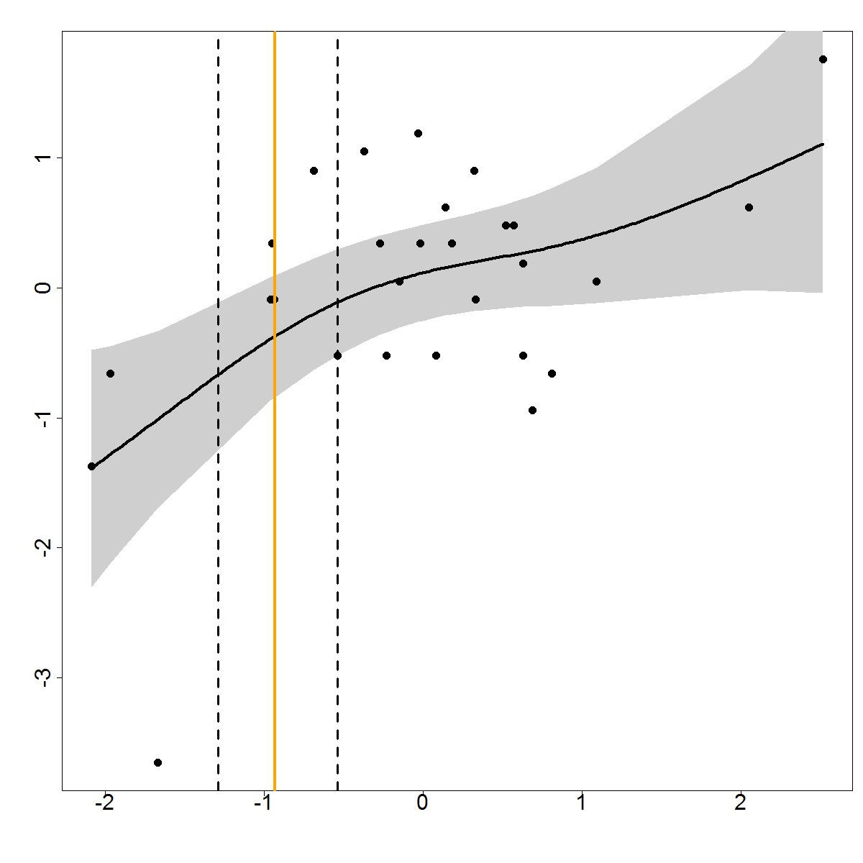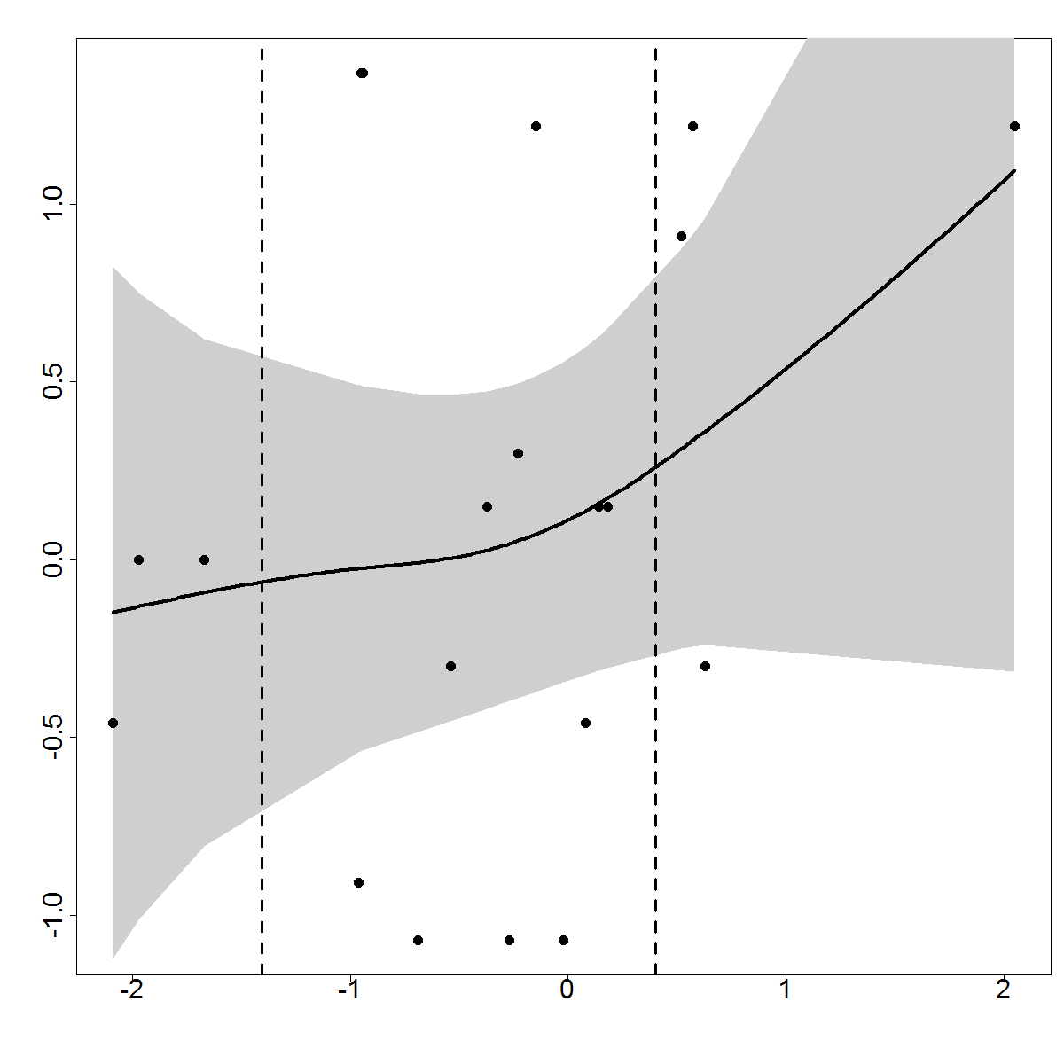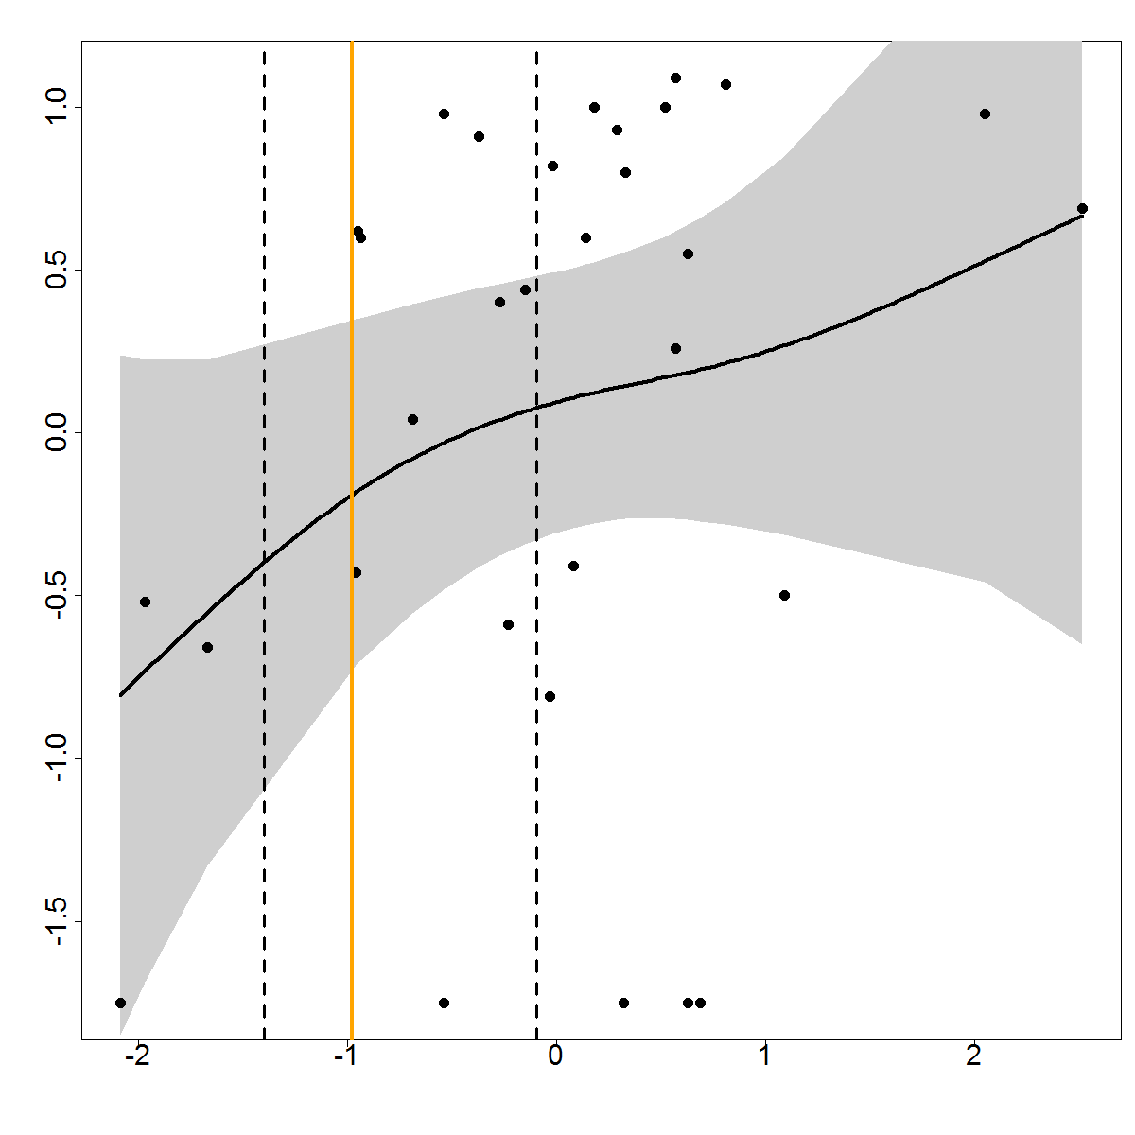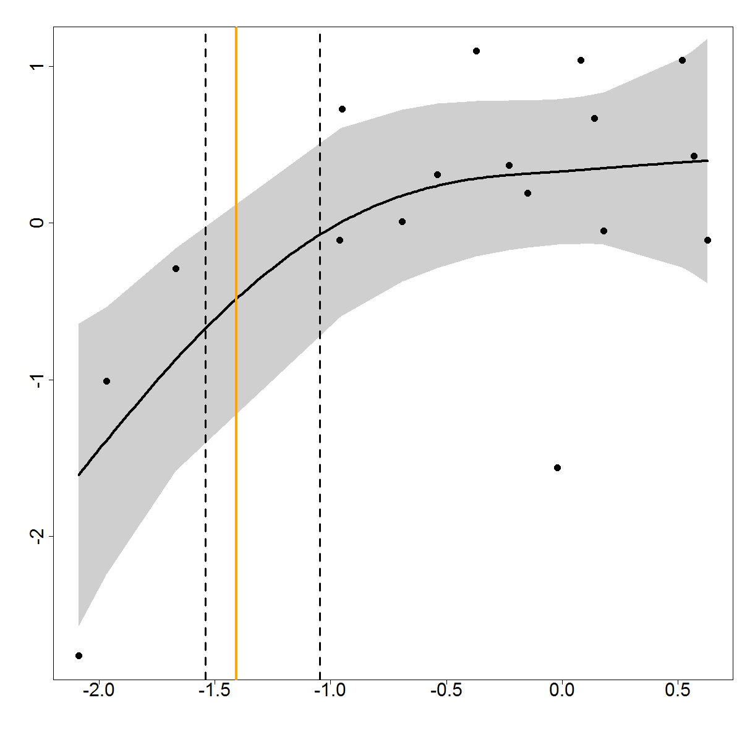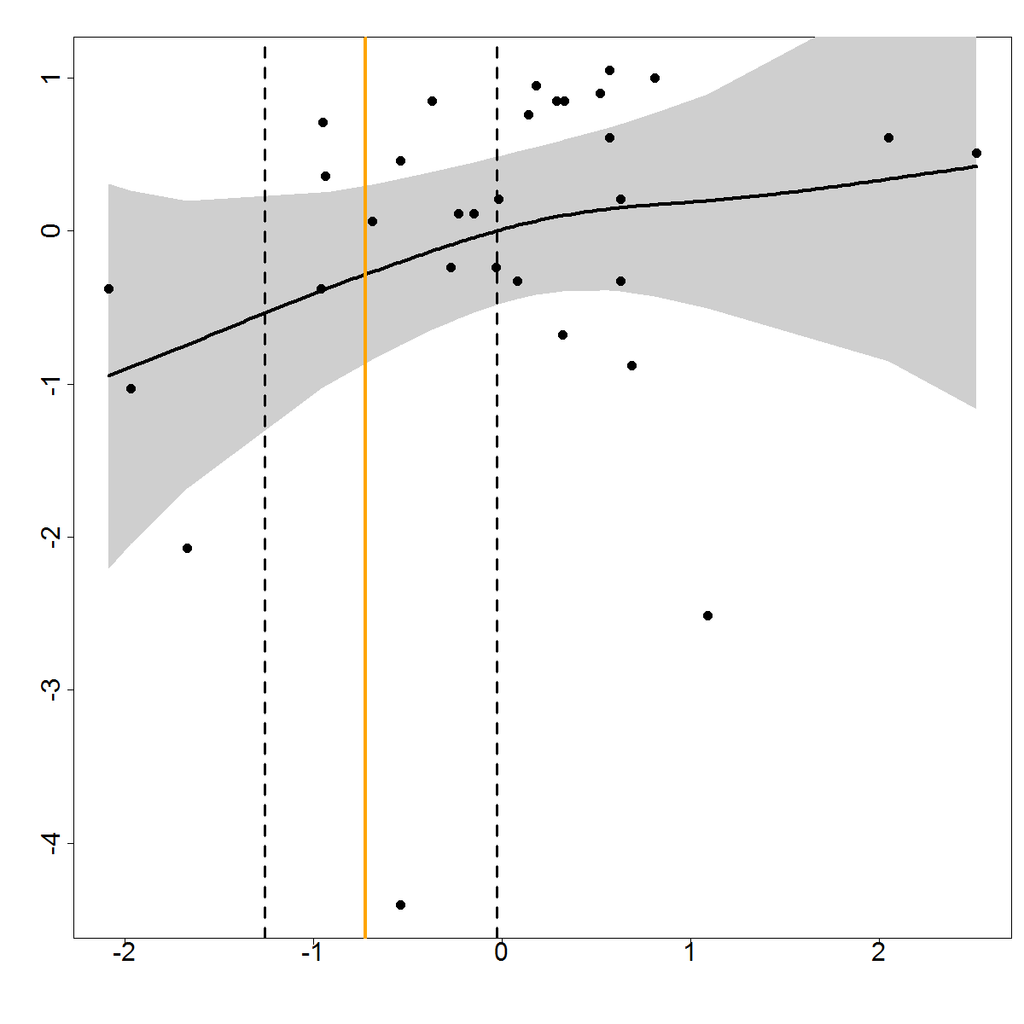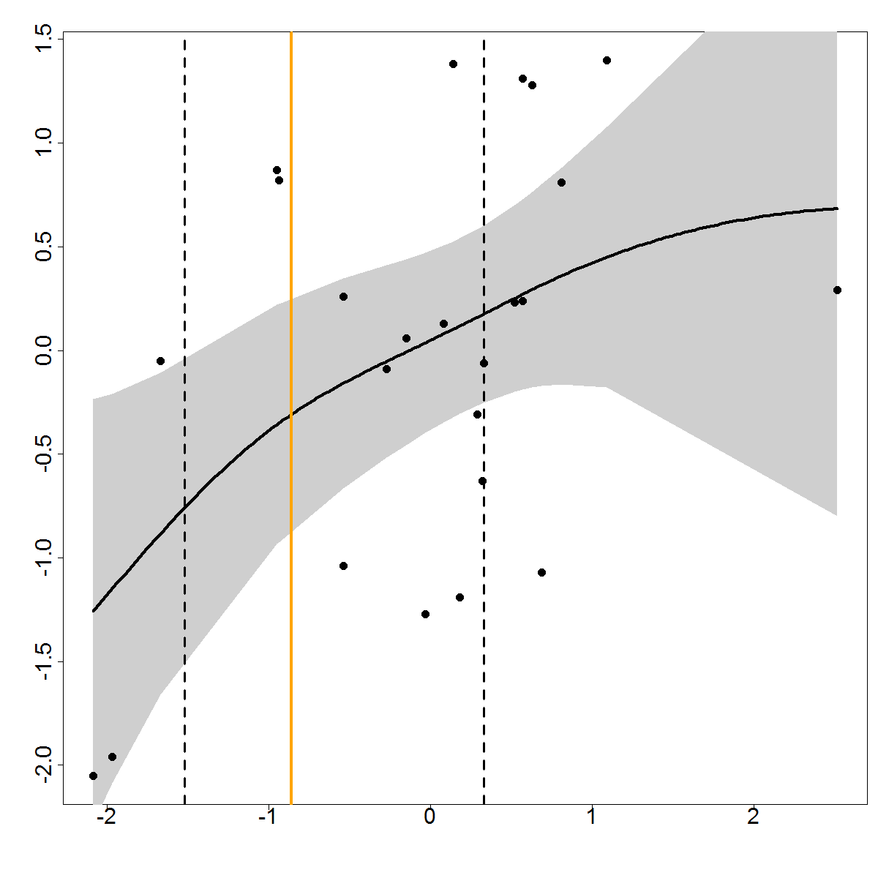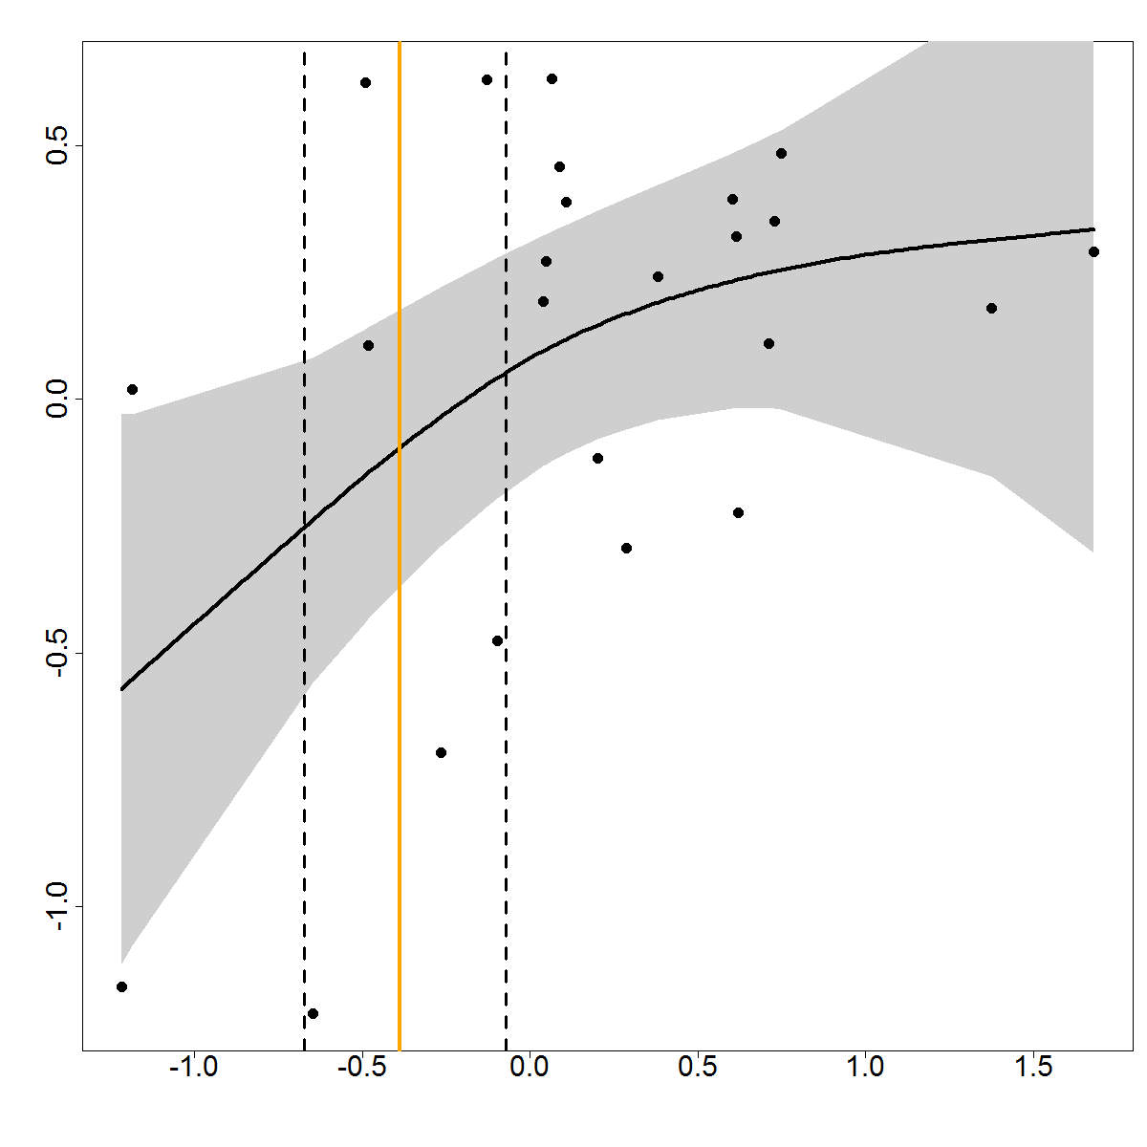 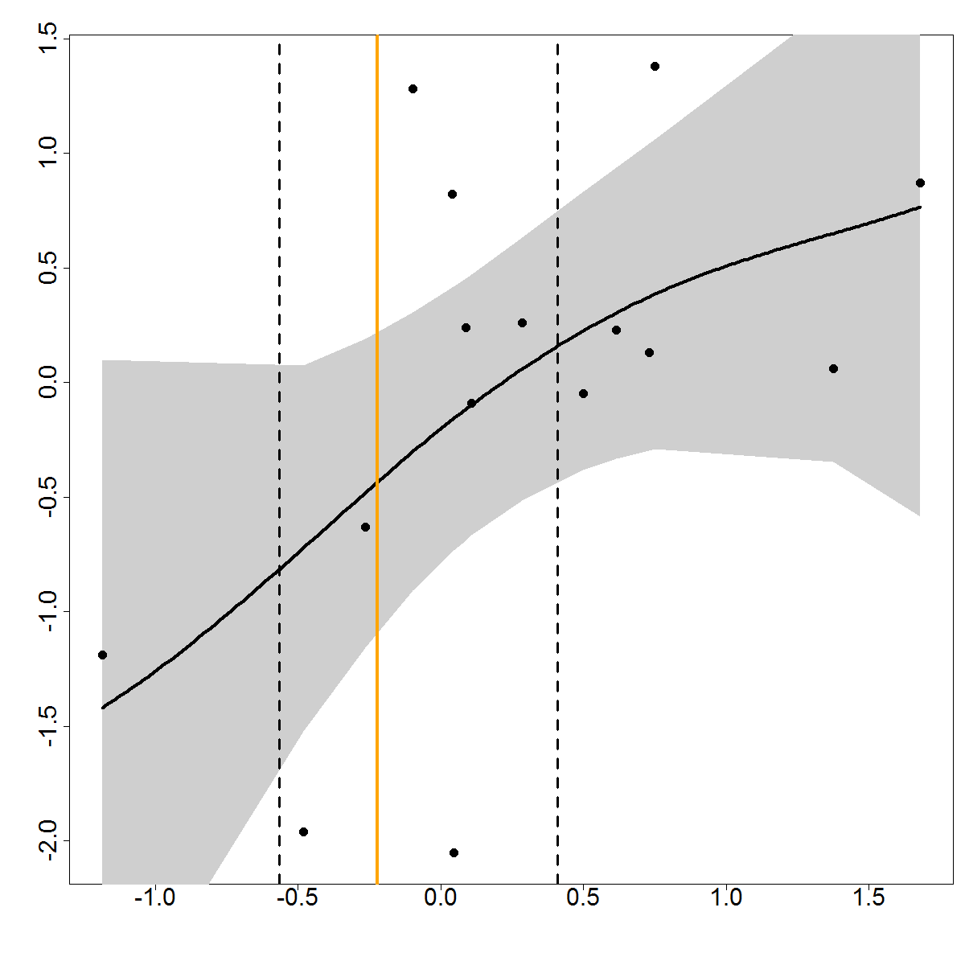 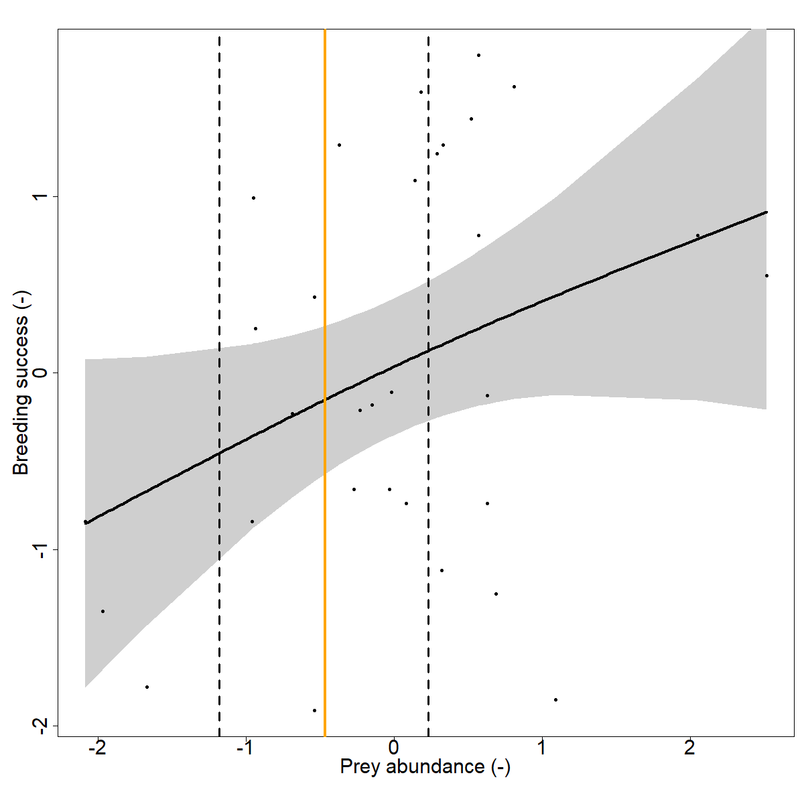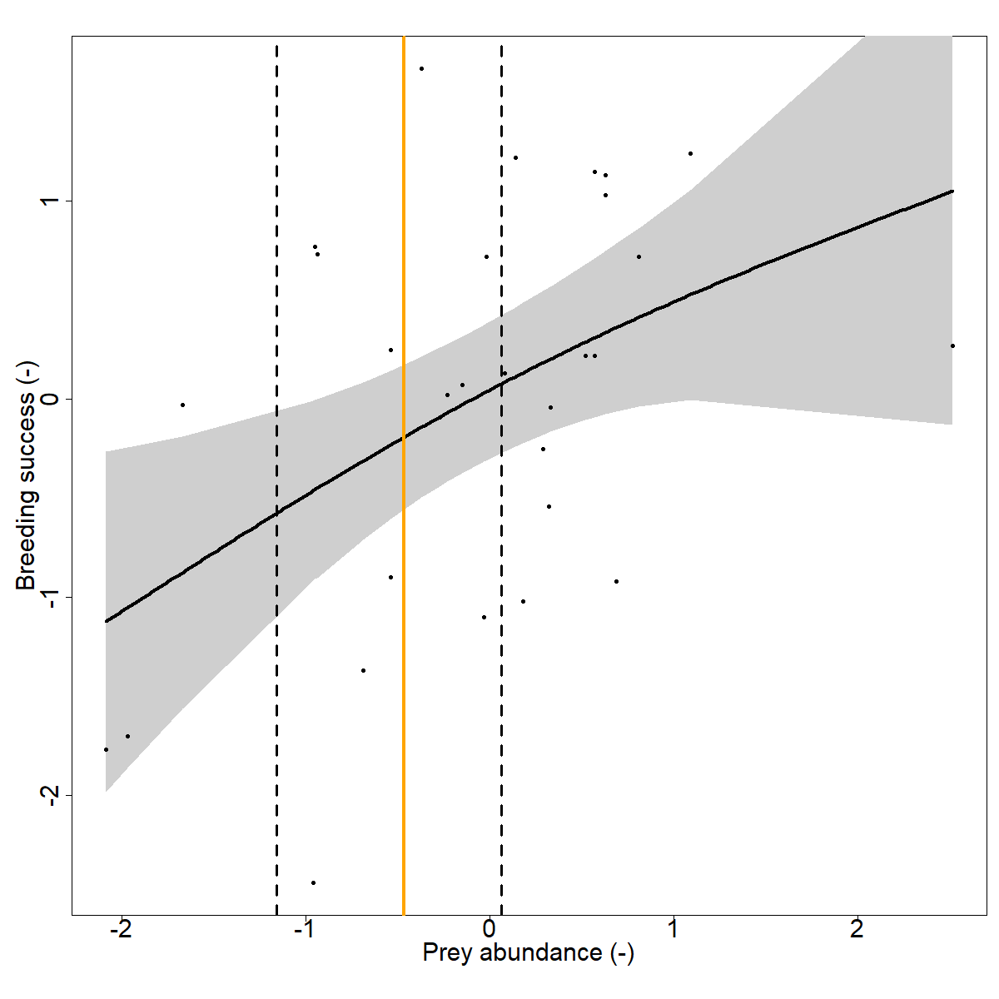

**III**

**II**

a

g

f

e

d

c

b

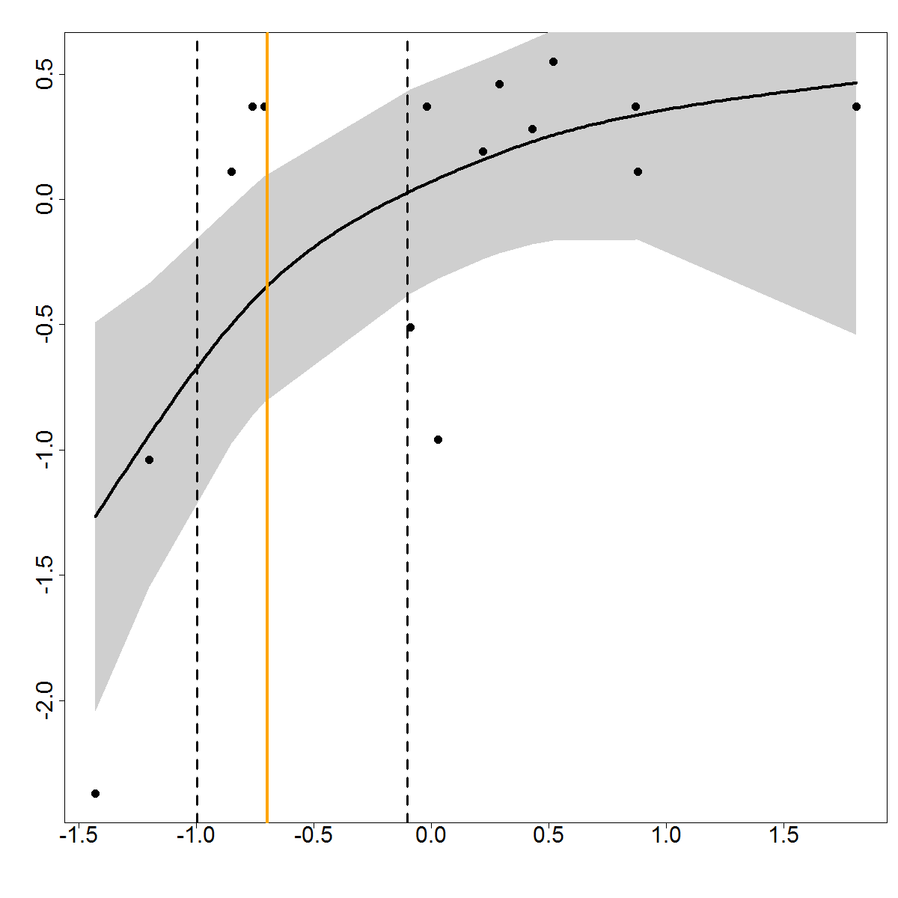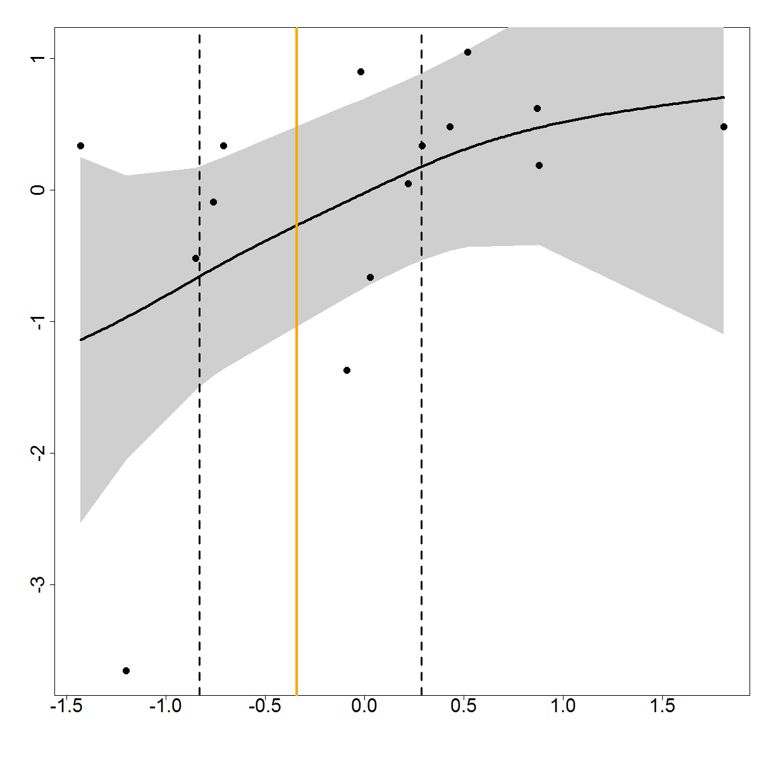 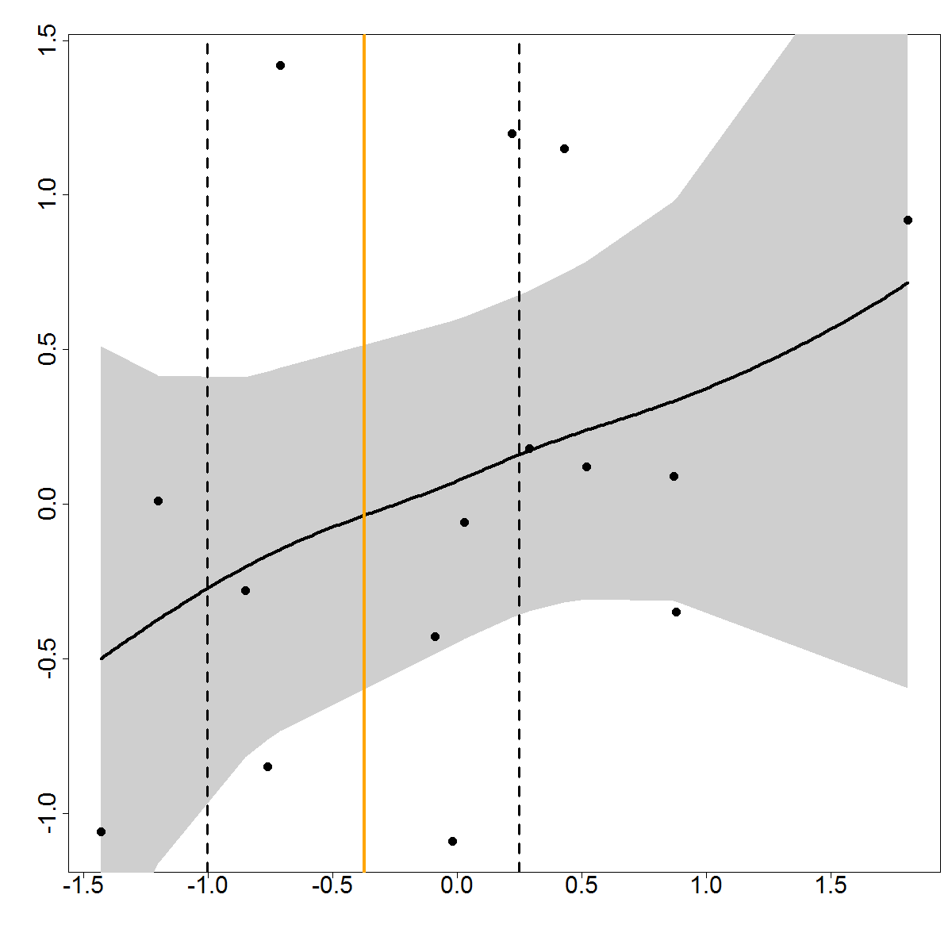

**IV**

d

c

b

a

